Multilevel Inheritance

📌 Definition:
# Source: AI Source: Provided by: [Data Path: Persons Table -> ID Column: 1, Name_En Column: Motasem Essam] -> From: [ChatGPT] on [12/9/2025]
Multilevel inheritance is a type of inheritance where a class is derived from another class, which is itself derived from another class, forming a chain of inheritance.

🧠 Simple idea:
# Source: AI Source: Provided by: [Data Path: Persons Table -> ID Column: 1, Name_En Column: Motasem Essam] -> From: [ChatGPT] on [12/9/2025]
Multilevel inheritance = “Grandparent → Parent → Child” 👴➡️👨➡️👦

🔍 Key characteristics:
# Source: AI Source: Provided by: [Data Path: Persons Table -> ID Column: 1, Name_En Column: Motasem Essam] -> From: [ChatGPT] on [12/9/2025]
- 🔗 Inheritance happens in multiple levels (chain)
- ♻️ Each level inherits from the previous one
- ➕ Child classes can add new features
- 🧩 Creates a hierarchical structure

📌 Example (Java-style):
# Source: AI Source: Provided by: [Data Path: Persons Table -> ID Column: 1, Name_En Column: Motasem Essam] -> From: [ChatGPT] on [12/9/2025]
Base class (Grandparent):
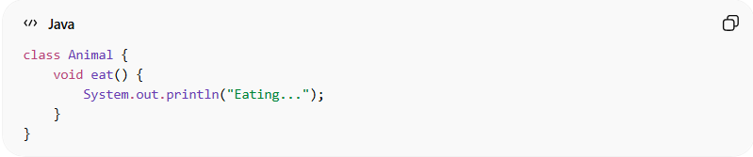
class Animal {
void eat() {
System.out.println("Eating...");
}
}

Intermediate class (Parent):
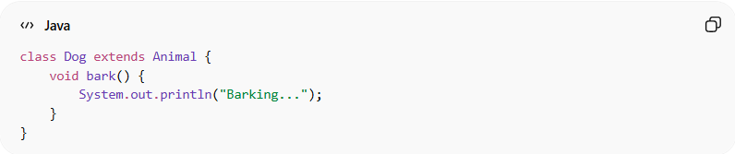
class Dog extends Animal {
void bark() {
System.out.println("Barking...");
}
}

Child class:
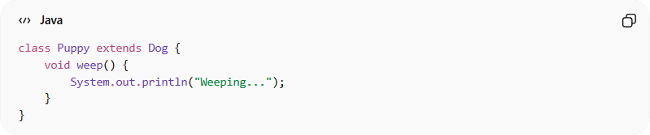
class Puppy extends Dog {
void weep() {
System.out.println("Weeping...");
}
}

Usage:
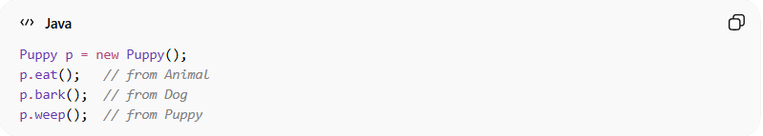
Puppy p = new Puppy();
p.eat(); // from Animal
p.bark(); // from Dog
p.weep(); // from Puppy
👉 Puppy inherits from Dog, and Dog inherits from Animal

🆚 Structure visualization:
# Source: AI Source: Provided by: [Data Path: Persons Table -> ID Column: 1, Name_En Column: Motasem Essam] -> From: [ChatGPT] on [12/9/2025]
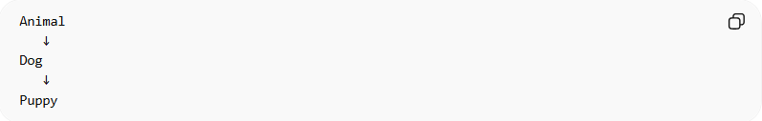
Animal
↓
Dog
↓
Puppy

🎯 Why multilevel inheritance is useful:
# Source: AI Source: Provided by: [Data Path: Persons Table -> ID Column: 1, Name_En Column: Motasem Essam] -> From: [ChatGPT] on [12/9/2025]
- ♻️ Maximizes code reuse
- 🧱 Builds layered relationships
- 🔄 Allows step-by-step extension of functionality
- 🧩 Useful for modeling real-world hierarchies

🎯 Summary:
# Source: AI Source: Provided by: [Data Path: Persons Table -> ID Column: 1, Name_En Column: Motasem Essam] -> From: [ChatGPT] on [12/9/2025]
Multilevel inheritance creates a chain of inheritance where each class derives from another, allowing features to be passed down across multiple levels.

